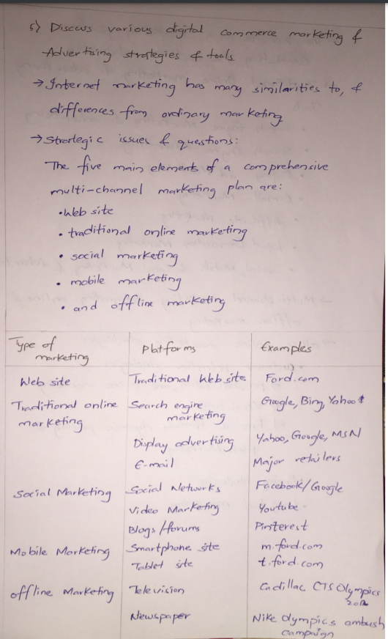

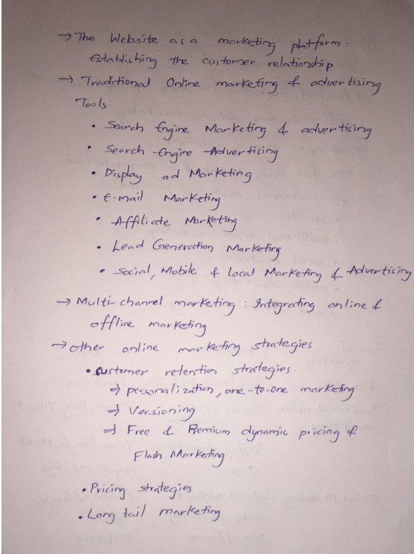

**IPR: Intellectual Property Rights**

* Intellectual Property is an idea, a design, an invention, which can ultimately give rise to a useful product and application.
* Intellectual property rights are the rights given to persons over the creations of their minds.

Three main types of protection:

* Copyright
* Patent
* Trademark law
* Patent means finding something new

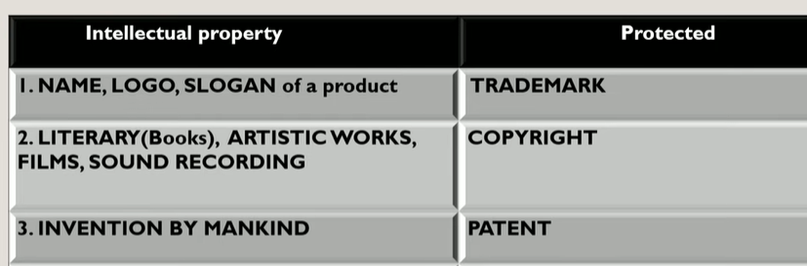

* Trademark gives an official recognition to the Logo in which different companies have unique logo’s

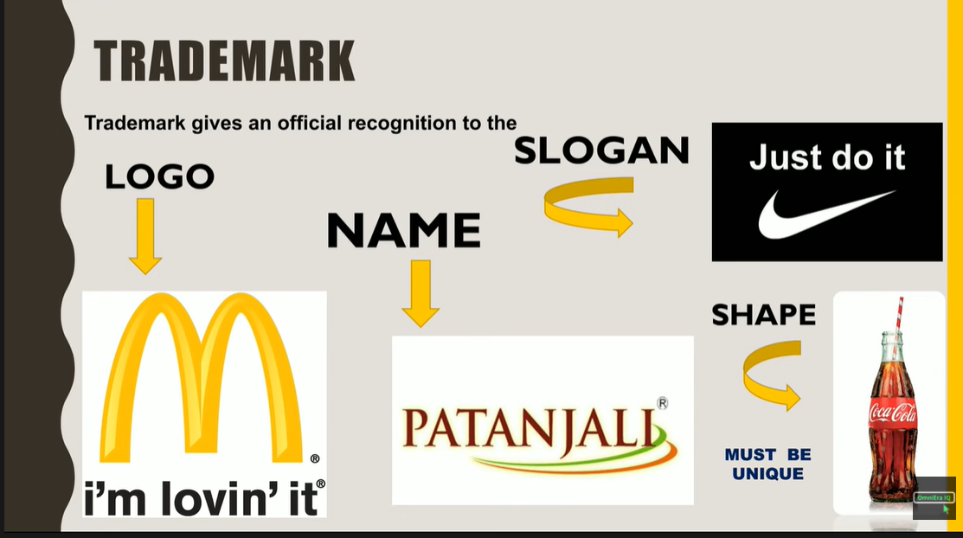

* Trademark is used to create the brand value
* To be protected from 3rd party using same name, slogan etc

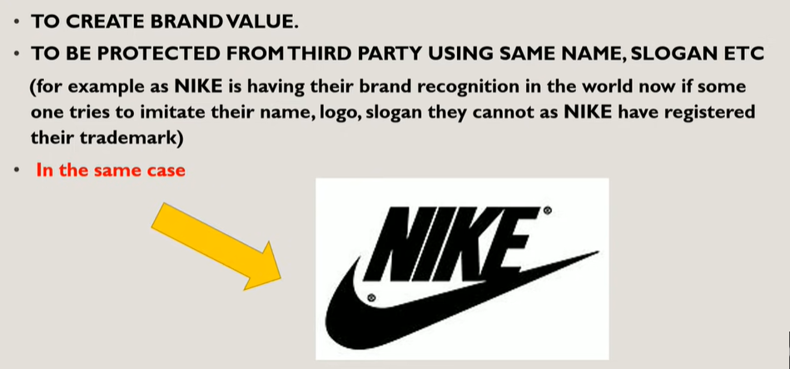

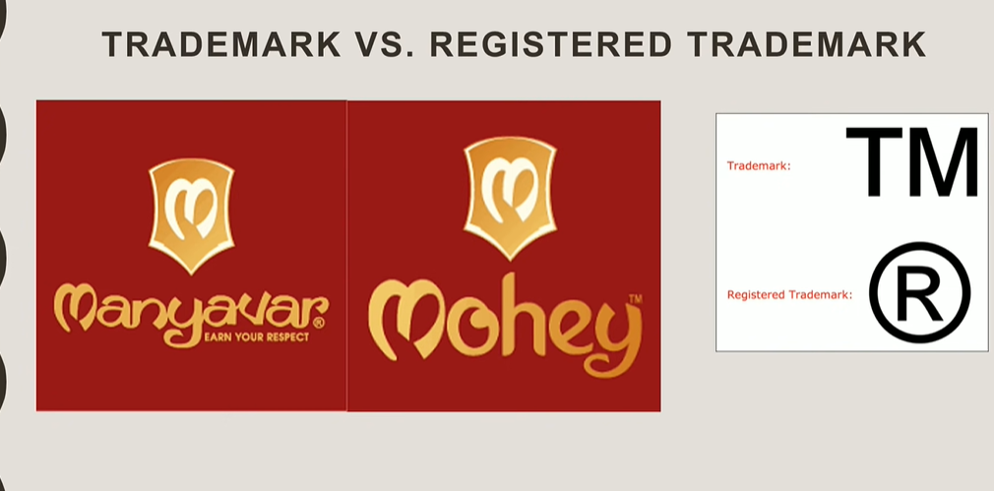

* TM means that they have applied for trademark in which it takes 18-24 months to get as registered trademark.
* Validity for trademark and registered trademark is 10 years. After 10 years the need to re-register the trademark.

**Patents:**

* Patents deal with human invention.
* A right which has granted to the owner of the invention to make use, manufacture and market the invention.
* There has an invention and not a discovery.
* It has a tenure of 20 years monopoly on ideas behind an invention.
  + Machines
  + Man-made products
  + Processing methods
* Encourage inventors
* Inventions must be new
* Promotes discrimination of new techniques through licensing

**Trademark:**

* Identify, distinguish goods, and indicate their source.
* Trademark gives an official recognition to the Logo in which different companies have unique logo’s
* Trademark is used to create the brand value.
* To be protected from 3rd party using same name, slogan etc.
* TM means that they have applied for trademark in which it takes 18-24 months to get as registered trademark.
* Validity for trademark and registered trademark is 10 years. After 10 years the need to re-register the trademark.
* Dilution (Behaviour) that weakens connection between trademark and product.

**Copyright:**

* Copyright (**or author's right**) is a legal term used to describe the rights that creators have over their literary and artistic works.
* Others should not copy their idea or works, so that if anyone uses their work and copy the content then it will lead to infringement.

Privacy – the control over one's personal data

